Functional Model
Employee Leave Request & Approval System
By
Dharani Manupati

1. Use Case Diagram
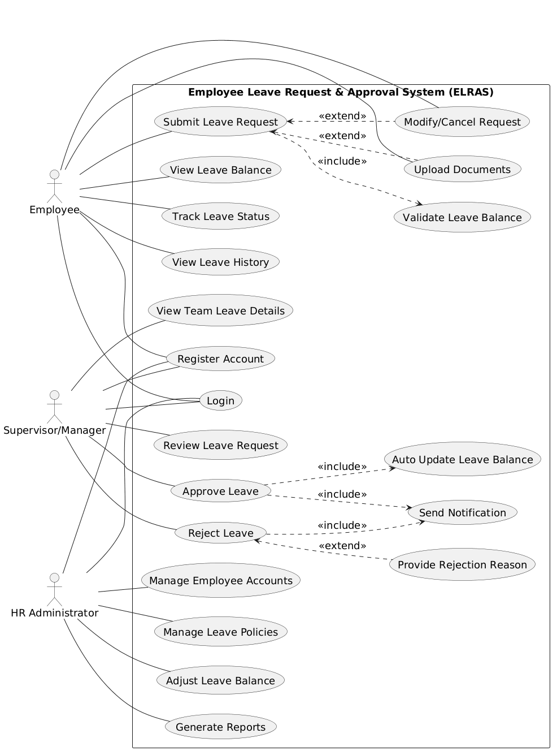
Figure.1 Use Case Diagram

Figure 1 shows use case diagram that illustrate how different users interact with the Employee Leave Request and Approval System. The diagram includes three main actors: Employee, Supervisor or Manager, and HR Administrator. Each actor has specific responsibilities in the system. The employee can register, log in, submit a leave request, check leave balance, track request status, and view leave history. While submitting a request, the employee may also upload documents or modify or cancel the request if needed. The system checks the leave balance before sending the request forward. The supervisor or manager receives the leave request and reviews it. Based on the decision, the manager can either approve or reject the request. If the request is approved, the system automatically updates the leave balance and sends a notification to the employee. If rejected, the manager provides a reason, and the system sends a rejection notification. The HR Administrator handles administrative tasks such as managing employee accounts, updating leave policies, adjusting leave balances, and generating reports. Overall, the diagram clearly shows the flow of actions and responsibilities among all users in the system.

2. Use Case Descriptions

Use Case 1: Login
Use Case Name: Login | ID: UC-01 | Importance Level: High
Primary Actor: Employee, Manager, HR Administrator | Use Case Type: Essential
Stakeholders and Interests: | Users need secure access. System must verify identity.
Brief Description: | User logs into the system using credentials.
Trigger: | User enters login details
Type: | External
Relationships: | Association: Employee, Manager, HR Administrator  Include: None  Extend: None  Generalization: None
Normal Flow of Events: | 1. User enters username and password  2. System validates credentials  3. System grants access
SubFlows: | S-1: User retries if credentials are wrong
Alternate/Exceptional Flows: | System denies access if login fails
Related Functional Requirement | 9, 10

Use Case 2: Register Account
Use Case Name: Register Account | ID: UC-02 | Importance Level: Medium
Primary Actor: Employee, Manager, HR Administrator | Use Case Type: Supporting
Stakeholders and Interests: | Users need account creation. System stores user data.
Brief Description: | User creates a new account.
Trigger: | User selects register option
Type: | External
Relationships: | Association: Employee, Manager, HR Administrator  Include: None  Extend: None  Generalization: None
Normal Flow of Events: | 1. User enters details  2. System validates data  3. Account is created
SubFlows: | S-1: Missing or invalid data
Alternate/Exceptional Flows: | Registration fails if data is incorrect
Associated Functional Requirements: | 36, 32, 33

Use Case 3: Submit Leave Request
Use Case Name: Submit Leave Request | ID: UC-03 | Importance Level: High
Primary Actor: Employee | Use Case Type: Essential
Stakeholders and Interests: | Employee wants leave approval. System checks request.
Brief Description: | Employee submits leave details.
Trigger: | Employee selects apply leave
Type: | External
Relationships: | Association: Employee  Include: Validate Leave Balance  Extend: Upload Documents, Modify or Cancel Request  Generalization: None
Normal Flow of Events: | 1. Employee enters leave details  2. System checks balance  3. Request is submitted  4. Manager is notified
SubFlows: | S-1: Balance validation
Alternate/Exceptional Flows: | Request fails if balance is insufficient
Associated Functional Requirements: | 1, 22, 23, 30

Use Case 4: View Leave Balance
Use Case Name: View Leave Balance | ID: UC-04 | Importance Level: High
Primary Actor: Employee | Use Case Type: Essential
Stakeholders and Interests: | Employee wants correct balance.
Brief Description: | Employee views leave balance.
Trigger: | Employee selects view balance
Type: | External
Relationships: | Association: Employee  Include: None  Extend: None  Generalization: None
Normal Flow of Events: | 1. Employee requests balance  2. System displays balance
SubFlows: | S-1: Fetch balance data
Alternate/Exceptional Flows: | Error if data not available
Associated Functional Requirements: | 2, 16

Use Case 5: Track Leave Status
Use Case Name: Track Leave Status | ID: UC-05 | Importance Level: High
Primary Actor: Employee | Use Case Type: Essential
Stakeholders and Interests: | Employee wants status updates.
Brief Description: | Employee checks leave request status.
Trigger: | Employee selects track status
Type: | External
Relationships: | Association: Employee  Include: None  Extend: None  Generalization: None
Normal Flow of Events: | 1. Employee selects request  2. System shows status
SubFlows: | S-1: Retrieve status
Alternate/Exceptional Flows: | No records found
Associated Functional Requirements: | 3

Use Case 6: Modify or Cancel Request
Use Case Name: Modify or Cancel Request | ID: UC-06 | Importance Level: Medium
Primary Actor: Employee | Use Case Type: Supporting
Stakeholders and Interests: | Employee wants to update or cancel request.
Brief Description: | Employee modifies or cancels a pending request.
Trigger: | Employee selects modify or cancel option
Type: | External
Relationships: | Association: Employee  Include: None  Extend: Submit Leave Request  Generalization: None
Normal Flow of Events: | 1. Employee selects request  2. Employee updates or cancels  3. System saves changes
SubFlows: | S-1: Check request status
Alternate/Exceptional Flows: | Cannot modify after approval
Associated Functional Requirements: | 4, 5

Use Case 7: Upload Documents
Use Case Name: Upload Documents | ID: UC-07 | Importance Level: Medium
Primary Actor: Employee | Use Case Type: Supporting
Stakeholders and Interests: | Employee wants to attach proof. System stores documents.
Brief Description: | Employee uploads supporting documents for leave.
Trigger: | Employee selects upload option during request
Type: | External
Relationships: | Association: Employee  Include: None  Extend: Submit Leave Request  Generalization: None
Normal Flow of Events: | 1. Employee selects file  2. System uploads document  3. File is linked to request
SubFlows: | S-1: File validation
Alternate/Exceptional Flows: | Upload fails if file format is invalid
Associated Functional Requirements: | 8

Use Case 8: Review Leave Request
Use Case Name: Review Leave Request | ID: UC-08 | Importance Level: High
Primary Actor: Supervisor/Manager | Use Case Type: Essential
Stakeholders and Interests: | Manager wants to review request details.
Brief Description: | Manager reviews employee leave request.
Trigger: | Manager receives leave request notification
Type: | External
Relationships: | Association: Supervisor/Manager  Include: None  Extend: None  Generalization: None
Normal Flow of Events: | 1. Manager opens request  2. Manager checks details  3. Manager prepares decision
SubFlows: | S-1: View employee details
Alternate/Exceptional Flows: | Request not found
Associated Functional Requirements: | 11, 12, 16

Use Case 9: Approve Leave
Use Case Name: Approve Leave | ID: UC-09 | Importance Level: High
Primary Actor: Supervisor/Manager | Use Case Type: Essential
Stakeholders and Interests: | Employee wants approval. System updates records.
Brief Description: | Manager approves leave request.
Trigger: | Manager selects approve option
Type: | External
Relationships: | Association: Supervisor/Manager  Include: Auto Update Leave Balance, Send Notification  Extend: None  Generalization: None
Normal Flow of Events: | 1. Manager approves request  2. System updates balance  3. Notification is sent
SubFlows: | S-1: Balance update
Alternate/Exceptional Flows: | Approval fails if system error occurs
Associated Functional Requirements: | 13, 21, 25

Use Case 10: Reject Leave
Use Case Name: Reject Leave | ID: UC-10 | Importance Level: High
Primary Actor: Supervisor/Manager | Use Case Type: Essential
Stakeholders and Interests: | Employee wants clear decision.
Brief Description: | Manager rejects leave request.
Trigger: | Manager selects reject option
Type: | External
Relationships: | Association: Supervisor/Manager  Include: Send Notification  Extend: Provide Rejection Reason  Generalization: None
Normal Flow of Events: | 1. Manager rejects request  2. Manager provides reason  3. Notification is sent
SubFlows: | S-1: Enter rejection reason
Alternate/Exceptional Flows: | Rejection fails if reason not provided
Associated Functional Requirements: | 13, 25

Use Case 11: Provide Rejection Reason
Use Case Name: Provide Rejection Reason | ID: UC-11 | Importance Level: Medium
Primary Actor: Supervisor/Manager | Use Case Type: Supporting
Stakeholders and Interests: | Employee wants clear explanation.
Brief Description: | Manager enters reason for rejection.
Trigger: | Triggered during leave rejection
Type: | Internal
Relationships: | Association: Supervisor/Manager  Include: None  Extend: Reject Leave  Generalization: None
Normal Flow of Events: | 1. Manager enters reason  2. System saves reason
SubFlows: | S-1: Input validation
Alternate/Exceptional Flows: | Error if reason is empty
Associated Functional Requirements: | 14

Use Case 12: View Team Leave Details
Use Case Name: View Team Leave Details | ID: UC-12 | Importance Level: Medium
Primary Actor: Supervisor/Manager | Use Case Type: Supporting
Stakeholders and Interests: | Manager wants team leave visibility.
Brief Description: | Manager views leave details of team members.
Trigger: | Manager selects team leave option
Type: | External
Relationships: | Association: Supervisor/Manager  Include: None  Extend: None  Generalization: None
Normal Flow of Events: | 1. Manager selects team view  2. System displays leave details
SubFlows: | S-1: Fetch team data
Alternate/Exceptional Flows: | No data available
Associated Functional Requirements: | 15, 29

Use Case 13: Manage Leave Policies
Use Case Name: Manage Leave Policies | ID: UC-13 | Importance Level: High
Primary Actor: HR Administrator | Use Case Type: Essential
Stakeholders and Interests: | HR wants control over leave rules.
Brief Description: | HR defines or updates leave policies.
Trigger: | HR selects policy management option
Type: | External
Relationships: | Association: HR Administrator  Include: None  Extend: None  Generalization: None
Normal Flow of Events: | 1. HR enters policy details  2. System saves policy
SubFlows: | S-1: Validate policy data
Alternate/Exceptional Flows: | Update fails if data is invalid
Associated Functional Requirements: | 17

Use Case 14: Adjust Leave Balance
Use Case Name: Adjust Leave Balance | ID: UC-14 | Importance Level: High
Primary Actor: HR Administrator | Use Case Type: Essential
Stakeholders and Interests: | HR needs to correct leave balance.
Brief Description: | HR updates employee leave balance.
Trigger: | HR selects adjust balance option
Type: | External
Relationships: | Association: HR Administrator  Include: None  Extend: None  Generalization: None
Normal Flow of Events: | 1. HR selects employee  2. HR updates balance  3. System saves changes
SubFlows: | S-1: Validate input
Alternate/Exceptional Flows: | Update fails if data is incorrect
Associated Functional Requirements: | 18

Use Case 15: Generate Reports
Use Case Name: Generate Reports | ID: UC-15 | Importance Level: Medium
Primary Actor: HR Administrator | Use Case Type: Supporting
Stakeholders and Interests: | HR needs reports for analysis.
Brief Description: | HR generates leave usage reports.
Trigger: | HR selects generate report option
Type: | External
Relationships: | Association: HR Administrator  Include: None  Extend: None  Generalization: None
Normal Flow of Events: | 1. HR selects report type  2. System generates report  3. Report is displayed or downloaded
SubFlows: | S-1: Data processing
Alternate/Exceptional Flows: | Report generation fails if data missing
Associated Functional Requirements: | 19, 27

Use Case 16: Manage Employee Accounts
Use Case Name: Manage Employee Accounts | ID: UC-16 | Importance Level: High
Primary Actor: HR Administrator | Use Case Type: Essential
Stakeholders and Interests: | HR manages user access.
Brief Description: | HR enables or disables employee accounts.
Trigger: | HR selects account management option
Type: | External
Relationships: | Association: HR Administrator  Include: None  Extend: None  Generalization: None
Normal Flow of Events: | 1. HR selects employee  2. HR updates account status  3. System saves changes
SubFlows: | S-1: Account validation
Alternate/Exceptional Flows: | Action fails if system error occurs
Associated Functional Requirements: | 32

Use Case 17: Validate Leave Balance
Use Case Name: Validate Leave Balance | ID: UC-17 | Importance Level: High
Primary Actor: System | Use Case Type: Internal
Stakeholders and Interests: | System ensures valid leave request. Employee avoids errors.
Brief Description: | System checks if enough leave balance exists.
Trigger: | Triggered during leave request submission
Type: | Internal
Relationships: | Association: System  Include: None  Extend: None  Generalization: None
Normal Flow of Events: | 1. System checks leave balance  2. System validates request
SubFlows: | S-1: Retrieve balance data
Alternate/Exceptional Flows: | Request blocked if balance is insufficient
Associated Functional Requirements: | 22

Use Case 18: Auto Update Leave Balance
Use Case Name: Auto Update Leave Balance | ID: UC-18 | Importance Level: High
Primary Actor: System | Use Case Type: Internal
Stakeholders and Interests: | System maintains correct records.
Brief Description: | System updates leave balance after approval.
Trigger: | Triggered after leave approval
Type: | Internal
Relationships: | Association: System  Include: None  Extend: None  Generalization: None
Normal Flow of Events: | 1. System deducts approved leave  2. System updates balance
SubFlows: | S-1: Data update
Alternate/Exceptional Flows: | Update fails if system error occurs
Associated Functional Requirements: | 21

Use Case 19: Send Notification
Use Case Name: Send Notification | ID: UC-19 | Importance Level: High
Primary Actor: System | Use Case Type: Internal
Stakeholders and Interests: | Users want timely updates.
Brief Description: | System sends notification for leave updates.
Trigger: | Triggered during approval or rejection
Type: | Internal
Relationships: | Association: System  Include: None  Extend: None  Generalization: None
Normal Flow of Events: | 1. System generates message  2. Notification is sent to user
SubFlows: | S-1: Message creation
Alternate/Exceptional Flows: | Notification fails if network issue occurs
Associated Functional Requirements: | 6, 11, 25

Use Case 20: Provide Rejection Reason
Use Case Name: Provide Rejection Reason | ID: UC-20 | Importance Level: Medium
Primary Actor: Supervisor/Manager | Use Case Type: Supporting
Stakeholders and Interests: | Employee needs clear reason.
Brief Description: | Manager enters reason for rejection.
Trigger: | Triggered during leave rejection
Type: | Internal
Relationships: | Association: Supervisor/Manager  Include: None  Extend: Reject Leave  Generalization: None
Normal Flow of Events: | 1. Manager enters reason  2. System saves reason
SubFlows: | S-1: Validate input
Alternate/Exceptional Flows: | Error if reason is empty
Associated Functional Requirements: | 14

3. Activity Diagram
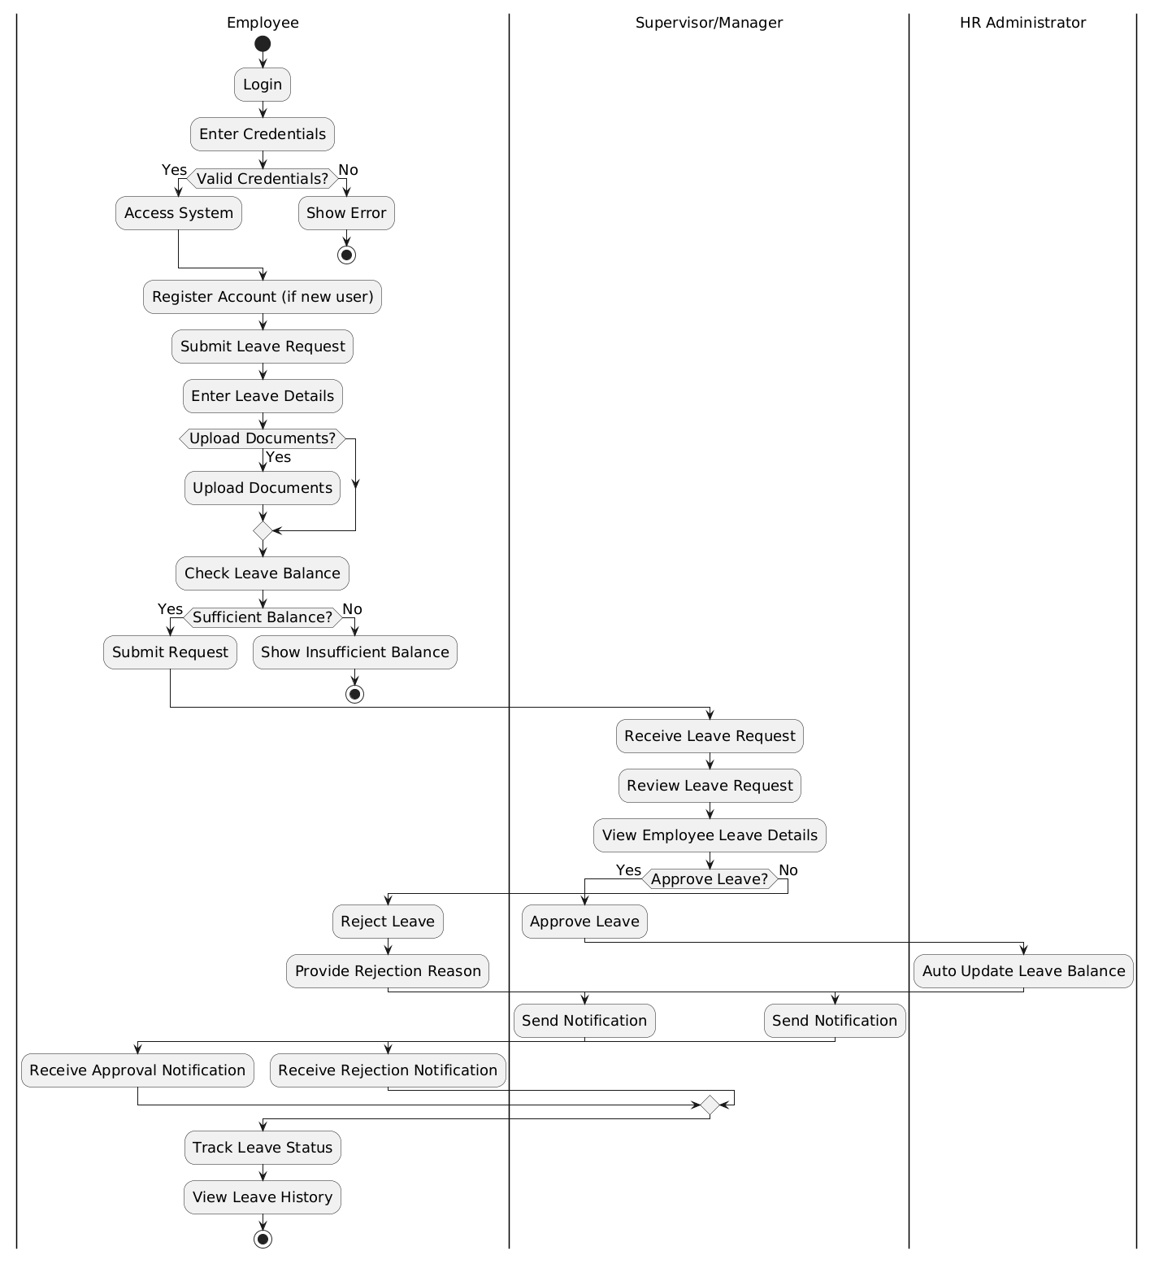
Figure.2 Activity Diagram
Figure 2. activity diagram shows the overall process of how the Employee Leave Request and Approval System works. The flow starts when the employee logs into the system and enters correct login details. Once access is granted, the employee fills in the leave request form and can also upload documents if needed. The system then checks whether the employee has enough leave balance. If the balance is sufficient, the request is sent to the supervisor or manager for review. The manager checks the request and decides to approve or reject it. If the request is approved, the HR Administrator updates the leave balance and the system sends a notification to the employee. If the request is rejected, a reason is provided and the employee is informed. At the end, the employee can view the leave status and history. The swimlanes clearly show the roles of each actor in the process.

